To: Xendit Payments Singapore Pte. Ltd. (201715598D)

LETTER OF AUTHORISATION

Dated: [20072026]

Engagement of Xendit Payments Singapore Pte. Ltd.’s services

This is to confirm that [Ananda Yasmin Farhanah], operating as [PT BLOOME CREATIVE INDONESIA] (the “Business”) with its registered address at Jl. Terusan Jakarta No.225, Antapani Kulon, Kec. Antapani, Kota Bandung, Jawa Barat 40291, is hereby authorised to apply for and use the services of Xendit Payments Singapore Pte. Ltd. and its related corporations.

Appointment of authorised person(s) and signator(ies)

The following individual(s) is/are hereby authorised to represent the Business in all matters related to obtaining and using the services of Xendit Payments Singapore Pte. Ltd., including:
- Conducting all necessary negotiations and processes relevant to setting up and using these services.
- Signing, executing, and delivering on behalf of the Business the Services Agreement, any related definitive agreements for the provision of services, and any amendments, forms, or related documents as required.
- Carrying out any other actions required for this purpose.

No. | Full Legal Name | NRIC/  Passport Number | Nationality | Designation | Specimen Signature
1 | Fazhal Darul Farhi | 3273272212910001 | Indonesia | Fazhal | 

I, Ananda Yasmin Farhanah, as the sole proprietor of PT BLOOME CREATIVE INDONESIA, certify that the above authorisation(s) are correct and in full effect.

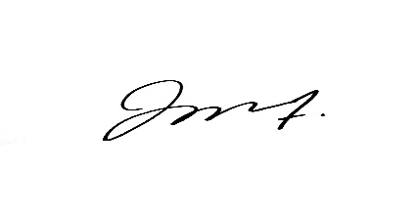
Ananda Yasmin Farhanah
Sole Proprietor

